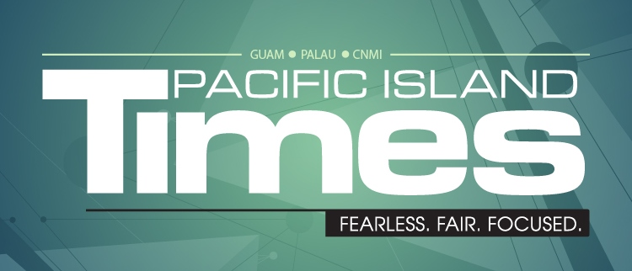

YES, I’d like my Pacific Island Times delivered to my doorstep.

SUBSCRIPTION FORM

Regular Subscription for one year (12 issues) = $25.00
Gift Subscription for one year (12 issues) = $25.00

Name ________________________________________
Mailing Address_________________________________
Phone ______________ Email:____________________

Make check payable to PACIFIC ISLAND TIMES
Send this form and check to:
PO BOX 11647 Tamuning GU 96931
Telephone: 671-929 4210
Email: pacificislandtimes@gmail.com

